**CUSTOMER RECOMMENDATIONS AT SHOPPING MALLS**

**INTRODUCTION**:

**Shopping** is an activity in which a customer browses the available goods or services presented by one or more retailers with the potential intent to purchase a suitable selection of them. A [typology of shopper types](https://en.wikipedia.org/wiki/Retail#Shopper_profiles) has been developed by scholars which identifies one group of shoppers as recreational shoppers,[[1]](https://en.wikipedia.org/wiki/Shopping#cite_note-1) that is, those who enjoy shopping and view it as a [leisure](https://en.wikipedia.org/wiki/Leisure" \o "Leisure)activity.[[2]](https://en.wikipedia.org/wiki/Shopping#cite_note-ReferenceA-2)

Shoppers' shopping [experiences](https://en.wikipedia.org/wiki/User_experience) may vary, based on a variety of factors including how the customer is treated, convenience, the type of goods being purchased, and mood.

Stores are divided into multiple categories of stores which sell a selected set of goods or services. Usually they are tiered by target demographics based on the [disposable income](https://en.wikipedia.org/wiki/Disposable_income) of the shopper. They can be tiered from cheap to pricey.

**Kinds of shopping**:

* Home shopping

#### Neighborhood shopping

#### Party shopping

### Window shopping

Malls, in particular, are contributing hugely to the development of organized retail. Malls are coming up both within cities and at the outskirts vowing to create destinations that will attract thousands of customers every day.

Consumer purchasing power is the main factor, which determines their buying behavior and brand of shopping malls. Shopping Malls are the places for the fun & entertainment, family outing, shopping and eating’s. In shopping Malls age factor is also one of the dominant factor in daily footfall. What I studied that in different shopping malls different age group consumers come and they impact on the buying behavior.

These days shopping model is being developed by using new technologies like **Artifical Intelligence** to make the work easier than the previous days.

We used Artifical Intelligence-Python for predicting the coustomers.Python is a object oriented programming language.

Keeping Python fun to use is an important goal of Python’s developers

Cython is also available. It translates a Python script into C and makes direct C-levelIts standard library is made up of many functions that come with Python when it is installed. On the Internet there are many other libraries available that make it possible for the Python language to do more things. These libraries make it a powerful language; it can do many different things.

**Python libraries for Data Science:**

**Many popular python tool boxes/libraries:**

* Numpy
* Pandas

**Visualization libraries:**

* Matplotlib
* Seaborn

**EVOLUTION**:

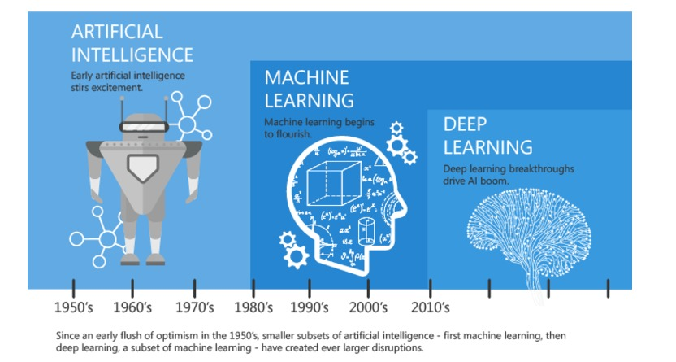**ARTIFICIAL INTELLIGENCE**:

Any technique which enables computers to mimic human behavior

**MACHINE LEARNING**:

Subset of AI techniques which use statistical methods to enable machines to improve with experiences

**DEEP LEARNING:**

Subset of ML which make the computation of multi-layer neural networks feasible

**OBJECTIVES OF RESEARCH:**

Assess the applicability, strengths, and weeknesses of the basic knowledge representation.

To recognize the existing customers from the database .

Frequently sending updates to the existing customers .

Explain the basic knowledge representation problem sloving and learning methods of Artifical Intelligence.

**PROBLEM STATEMENT:**

The customer recommendation at shopping malls is designed by using supervised Artifical Intelligence to recognize the existing customers from the database and frequently sending updates to the customers based on previously purchased goods.

**REVIEW OF LITERATURE**:

The customer recommendations at shopping mall sector is widely considered as one of the most important predictions using Artifical Intelligence.More and more Artifical Intelligence has been considered as a practice that facilitates customer recommendations at shopping malls performance through using data and information efficiently in the shopping sectors.Therefore,it is that is inorder to understand the relation between Artifical Intelligence and shopping sectors, we first need to understand what are the technologies used in shopping model.

Artifical Intelligence have been developed over the last few years not only as automated learning sysyem,but also a strategic provider that develops and integrates shopping sector infrastructures to facilitate and ensure the quality of service.

**DATA CLEANING:**

**STEP 1: Data Gathering:**

Collecting data allows to capture a record of past events so that we can use data analysis to find recurring patterns. From those patterns, we build predictive [models](https://www.datarobot.com/wiki/model) using artificial intelligence  that look for trends and predict future changes. Predictive models are only as good as the data from which they are built, so good data collection is crucial to develop high-performing models.

**STEP 2: Data Pre-processing**:

Beforeimplementing any modeling techniques, the dataset needs to be pre-processed.  The data need to be error-free and contain relevant information. For this we handle the missing data.

**STEP3: Feature Extraction**:

In this step we extract required information from whole dataset. Including more relevant features helps to improve prediction power. Here we decide which key factors are important and effect the output and which doesn’t. The feature which is completely unrelated to the output can be removed.

**STEP 4: Model Training:**

A common strategy is to take all available label data, and split it into training and evaluation subsets.

The rule of splitting the data is 80–20 percent training & testing sets respectively.

* Artifical Intelligence is using data to answer questions. So prediction is the step where we get to answer some questions. This is the point of all this work, where the value of machine learning is realized. We can finally use our model to predict.

**METHODOLOGY:**

**LIBRARIES USED:**

* glob
* dlib
* cv2
* pickle
* random
* facevec
* numpy

**EXTENTION:** Customer pickel

**Exploratory Data Analysis:**

**Exploratory data analysis** (**EDA**) is an approach to [analyzing](https://en.wikipedia.org/wiki/Data_analysis) [data sets](https://en.wikipedia.org/wiki/Data_set) to summarize their main characteristics.

We are performing data analysis on Customer recommendations at shopping malls

**STEP1: Importing libraries:**

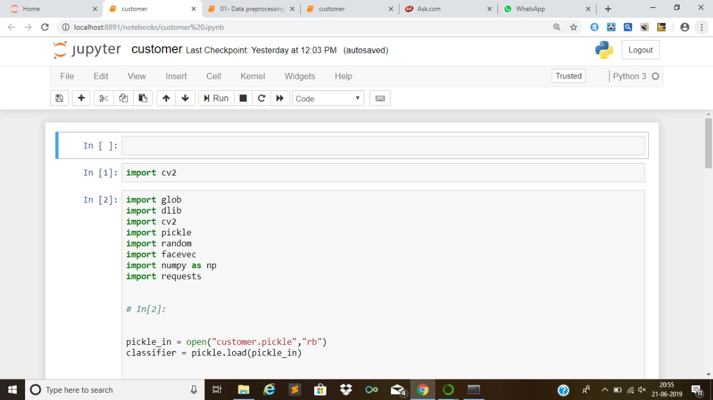

**ASSIGNING OF NAMES:**

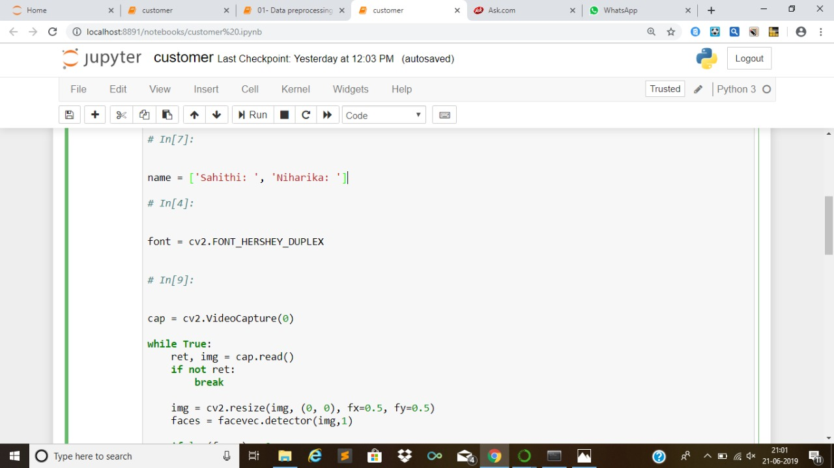

**RETRIVING IMAGES:**

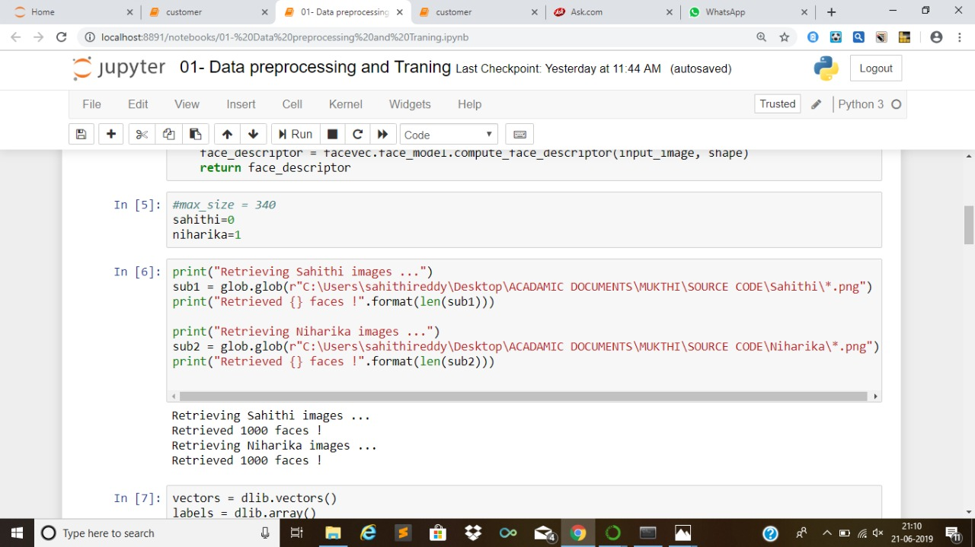

**READING OF IMAGIES**:



**SAHITHI IMAGES:**

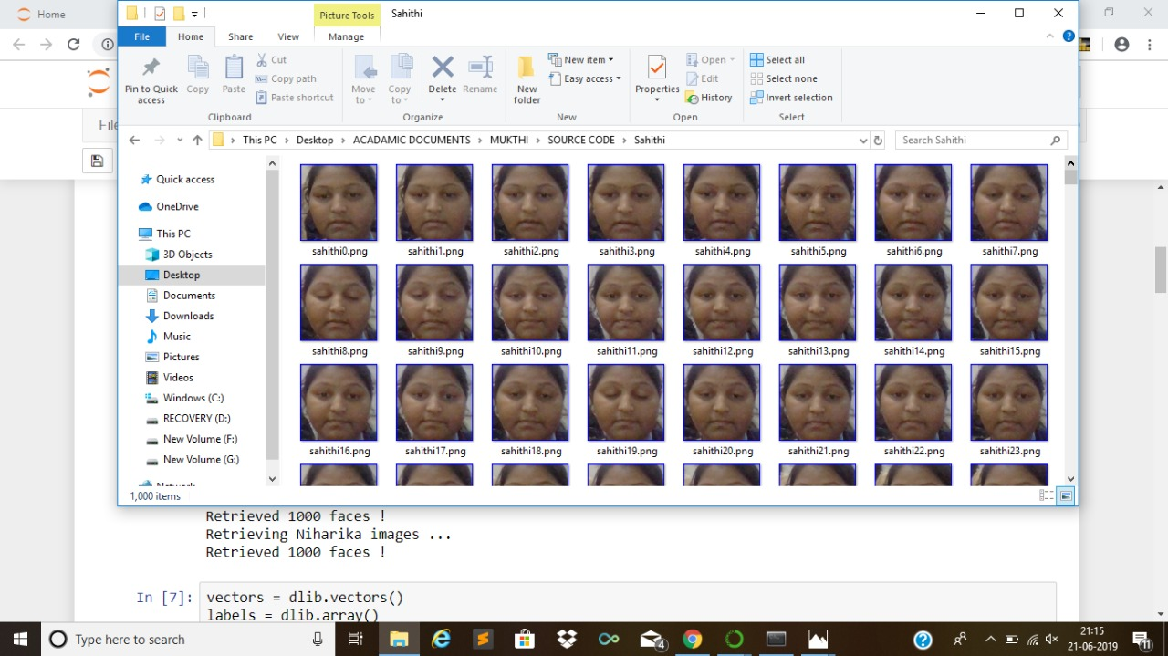

**NIHARIKA IMAGES**:

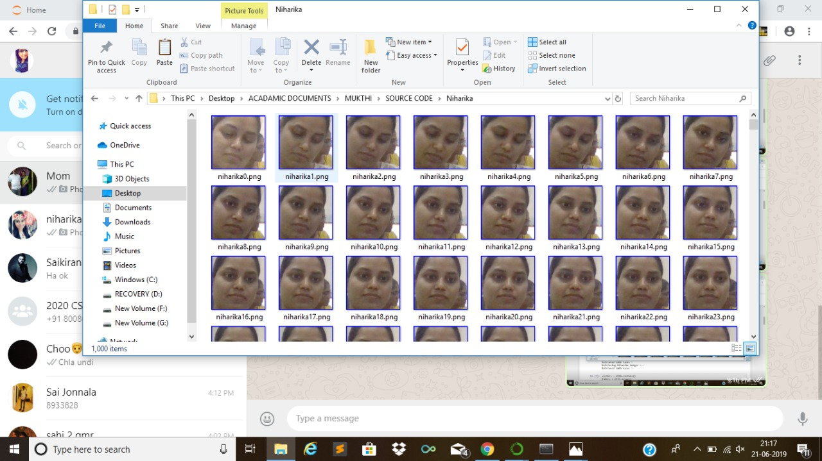

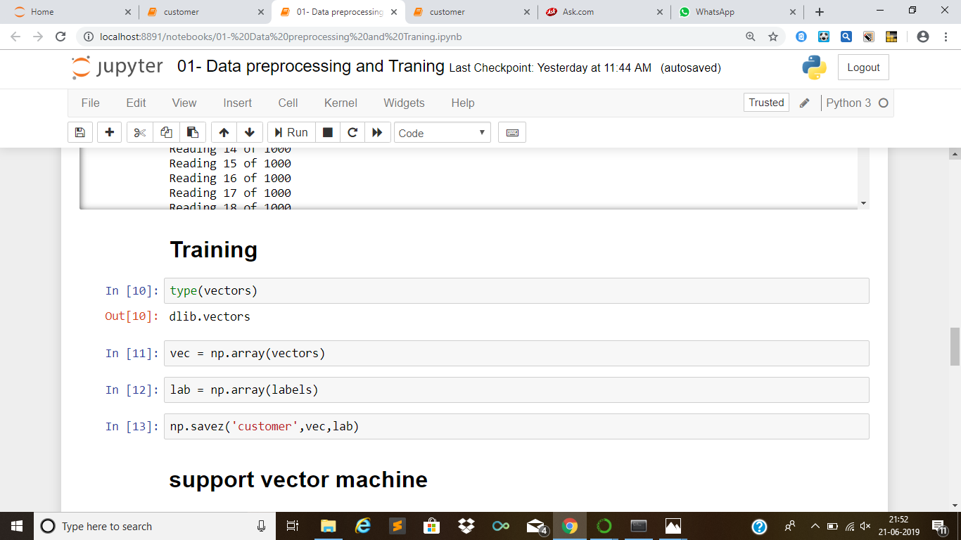**TRAINING**:

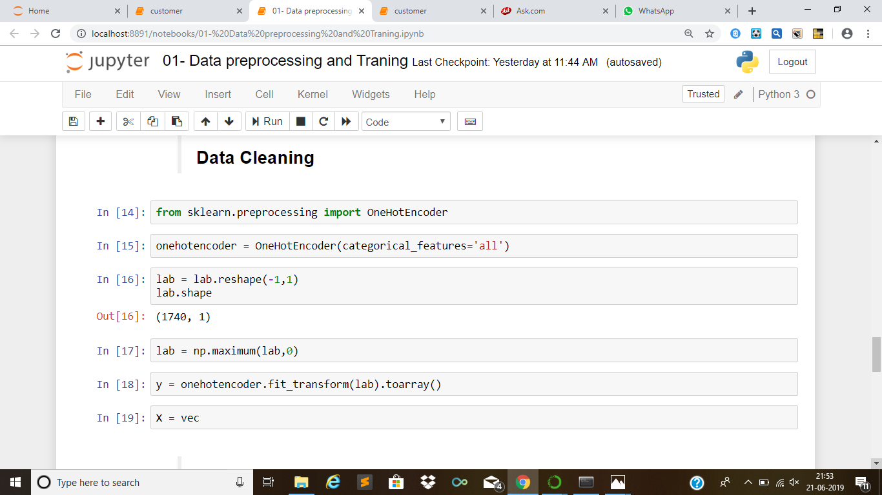

**DATA CLEANING:**

**TEST TRAIN SPLIT:**

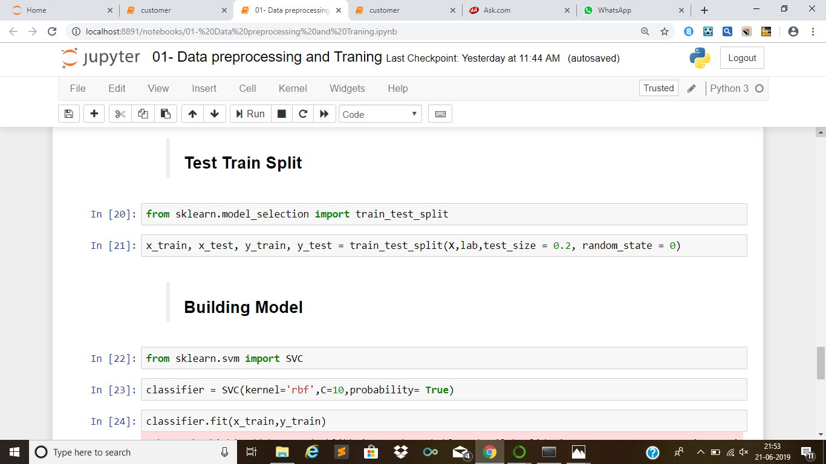

**BUILDING MODEL**:

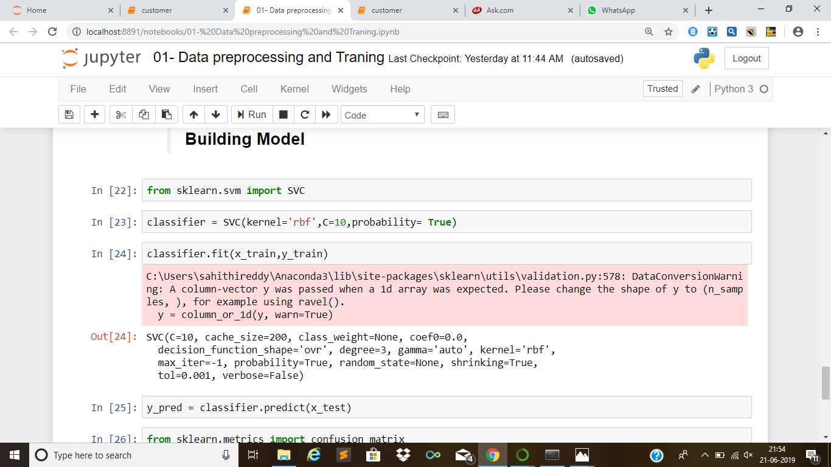

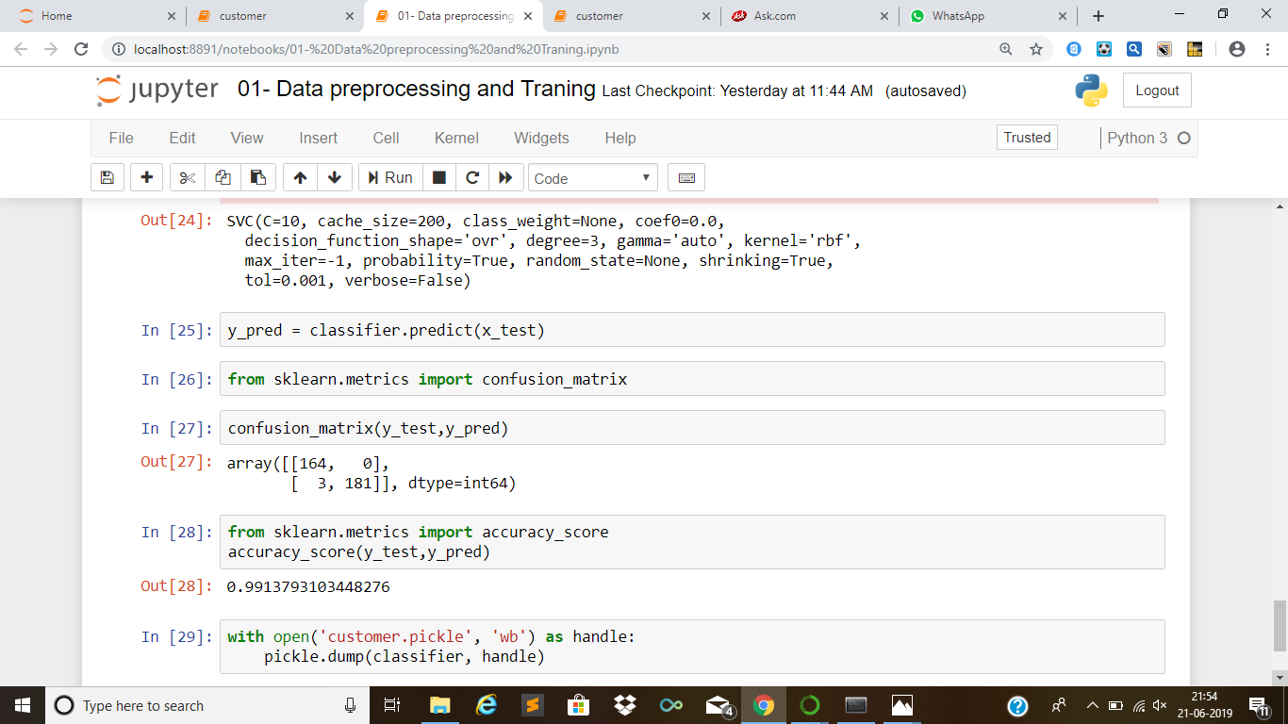

**FACIAL RECOGNTION:**

Facial recognition is a way of recognizing a human face through technology. A facial recognition system uses biometrics to map facial features from a photograph or video. It compares the information with a database of known faces to find a match. Facial recognition can help verify personal identity, but it also raises privacy issues.

But that’s where it gets complicated. If privacy is important to you, you probably want some control over how your personal information — your data — is used. And here’s the thing: your “faceprint” is data.

## **How facial recognition works?**

You might be good at recognizing faces. You probably find it a cinch to identify the face of a family member, friend, or acquaintance. You’re familiar with their facial features — their eyes, nose, mouth — and how they come together.

That’s how a facial recognition system works, but on a grand, algorithmic scale. Where you see a face, recognition technology sees data. That data can be stored and accessed. For instance, half of all American adults have their images stored in one or more facial-recognition databases that law enforcement agencies can search, according to a Georgetown University study.

So how does facial recognition work? Technologies vary, but here are the basic steps:

**Step 1.** A picture of your face is captured from a photo or video. Your face might appear alone or in a crowd. Your image may show you looking straight ahead or nearly in profile.

**Step 2**. Facial recognition software reads the geometry of your face. Key factors include the distance between your eyes and the distance from forehead to chin. The software identifies facial landmarks — one system identifies 68 of them — that are key to distinguishing your face. The result: your facial signature.



**Step 3**. Your facial signature — a mathematical formula — is compared to a database of known faces. And consider this: at least 117 million Americans have images of their faces in one or more police databases. According to a May 2018 report, the FBI has had access to 412 million facial images for searches.

**Step 4**. A determination is made. Your faceprint may match that of an image in a facial recognition system database.

I 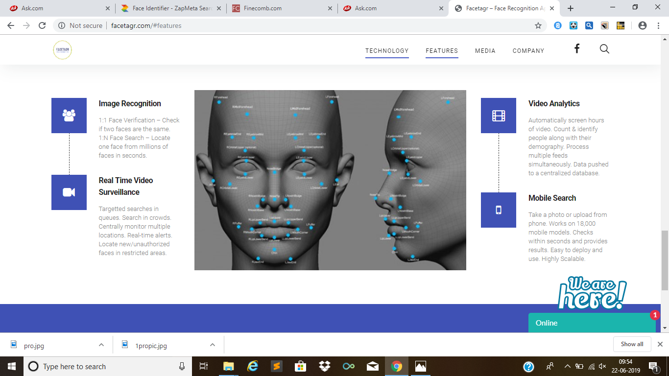

**BACK END TOOLS:**

* Visual studio
* C make

**FIGURES:**

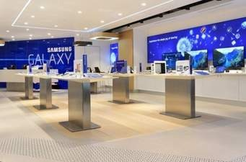 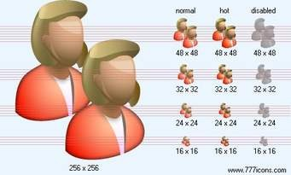 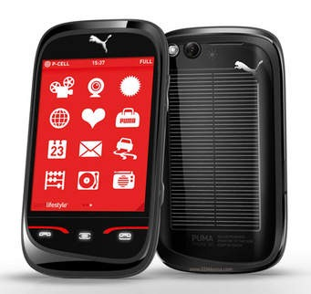

Samsung store Customer Purchased mobile

 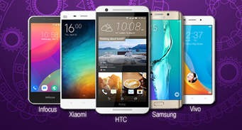

Database stored Updates

 Existing customer Niharika

**Conclusion:**

In this project , the concepts of Artifical Intelligence have been implemented for building a prediction model which can help in detecting health insurance charges claims made by the customers by training the model using supervised learning technique.